Digitalizing Vocational Training: Evaluation of an AI-Driven Personalized Skills Learning Platform for Youth Employability.

Cynthia Mwau, Corresponding author, Department of Mathematics and Actuarial Science, Kisii University, Email: cynthiamwende@kisiiuniversity.ac.ke
Sunday Adebisi, Director ARUA-CoE Unemployment and Skills Development, Nigeria,
Email: sadebsi@unilag.edu.ng

Abstract
The traditional systems have been marred with structural limitations which lead to persistent youth unemployment and skills mismatch in low-resource contexts. This study therefore, designs and evaluates an AI-enabled digital education ecosystem that integrates theoretical modules, AI-powered simulations, certified skill centers and entrepreneurship linkages to strengthen employability pathways and equitable training access. It conducted a pilot sttudy among youths aged (18-35 years) across rural, peri-urban and urban areas. Various statistical analysis tests were applied and the results indicated universal willingness to use the platform of 100%, with consistently high perception scores across all components (means > 4.5/5) and strong internal reliability (Cronbach’s α = 0.928). Significant differences across gender, age, education level or geographic location were evaluated using chi-square, Mann-Whitney U and Kruskal-Wallis tests. Urban participants reported significantly higher perceived usefulness of AI simulations compared to rural participants (p = 0.012). Correlation analysis revealed that intention to use was most strongly associated with addressing youth challenges with r = 0.49. Ordinal logistic regression identified that structured training pathway was the only significant predictor of higher reported use suggesting that youth adoption of AI-enabled skill training platforms is driven primarily by coherent, job-aligned progression structures rather than demographic factors.

Keywords: AI, Digitizing vocational training, Digital twin technology, Unemployment, Skills mismatch

Structured practitioner notes

- What is already known about this topic
- TVET are key players in equipping learners with practical and job-relevant skills for employment and entrepreneurship.
- Skills mismatch between what is taught in institutions of higher learning including TVET and universities and the labour market demand.
- Increased youth unemployment due to skill mismatch and changing dynamics of the labour market demand.
- Fragment policy approach towards youth empowerment and unemployment which has had minimal impact in reducing youth unemployment.
- Digital learning models and experiential learning theory emphasize the importance of hands-on and practice-based approaches to skill acquisition.
- Factors such as perceived usefulness and ease of use influence the adoption of digital learning technologies and highlighted by Technology Acceptance Model (TAM)
- There is increased adoption of AI in education through adaptive learning systems and simulation-based training tools.
- TVET systems have maintained a fragmented approach to training with limited integration of industry players and entrepreneurship support.

- What this paper adds
- Conceptualizes a new approach to TVET training by developing Di-TVET which is an integrated AI-enabled training, job-linkage and entrepreneurship/innovation incubation ecosystem.
- Demonstrates the role of embracing new technology in training by incorporating AI-powered simulations through digital twin environments hence enhancing practical skill acquisition and experiential learning.
- Provides empirical evidence that perceived usefulness, training pathway and simulation training are stronger drivers of technology adoption than demographic factors.
- Positions AI through Di-TVET as an enabling infrastructure that connects learning, employment and entrepreneurship pathways.
- Extends existing technology acceptance and experiential learning theories within the context of AI-enhanced vocational education by highlighting that training pathways in digital training are key drivers of technology adoption.

- Implications for practice and/or policy
- TVET institutions should adopt integrated approach that combine training, real world scenario simulation, job matching and entrepreneurship support hence ensuring that most graduates have a post training pathway and industry relevant skills.
- Tertiary education learning institutions should invest in digital twin and simulation-based learning environments as they improve learner engagement, competence and job readiness.
- Policymakers should prioritize ecosystem-based TVET reforms rather than fragmented, stand-alone interventions. They should ensure that the policy intervention target training, job market linkage and entrepreneurship pathways rather than addressing each as a stand along problem.
- Stronger alignment is needed between skills development training/education systems and industry skill requirements hence ensuring reduction of skills-labour market demand mismatch.
- Implementation strategies to be put in place for digital onboarding and support mechanisms to ensure inclusive access for diverse learner groups and physically challenged learners.

- Introduction
Africa’s population has grown to 1.5 billion as at 2020, with youth constituting the largest share of the working-age individuals (Onyeiwu, 2024). Despite these statistics, many young people still face pertinent levels of unemployment, underemployment and socio-economic exclusion (UNECA, 2017; British Council, 2025). This has led to many governments introducing youth empowerment policies geared towards expanded access to education which has not translated to into improved labour market outcomes but rather reinforcing cycles of inequality (Sele & Mukundi, 2024; Anyalebechi, 2015). However, the term youth empowerment wholesomely should encompass access to education, skills and economic participation aimed at mitigating challenges facing the youths (Audu et al., 2013). Most youth empowerment outcomes are largely shaped by gender and inclusion dynamics where inclusion of young women, rural youth, persons with disabilities and low-income youth enhance the impact factor of most interventions. This is because this cohort of individuals is more often than not faced with compounded challenges such as limited training opportunities, digital exclusion, constrained financial resources and socio-cultural constraints (Hope, 2012; UNECA, 2017; British Council, 2023).

Many policy interventions have been rolled out however youth unemployment and inequality remain pervasive. Recent studies have indicated that approximately 70% of African youth aged 25 to 29 work in precarious and informal positions without social protection (United Nations Office of the Special Adviser on Africa et al., 2025). Survey done by ILO strongly indicated that the NEET rate in sub-Saharan Africa had reached 21.9% in 2023 (ILO Brief, 2024) which was higher than the global average. TVET institutions were designed to align education with employment, demands. However, they often struggle to respond to the evolving industry requirements. This has led to limitations such as weak industry linkages, limited digitization, insufficient work-based learning, misaligned curricula, high tuition fees and lack of self-paced digital platforms (Mutisya et al., 2021; Princely, 2024; ILO, 2021). These factors have collectively further exacerbated skills mismatches and constrain access for marginalized youth.

Over the years the education sector has rapidly expanded and transformed due to digital technology which has also translated to transformation of the labour markets and skill acquisition spaces. This transformation has created a huge and urgent need for individuals to develop relevant digital competencies in order to remain competitive in the technology-driven world. Digitization has reshaped the industries as well as the skills required for meaningful participation in modern economies. The digitally transformed labour market has put a huge emphasis on digital literacy, problem-solving and adaptability skills as key requirements for navigating the labour market (Rêgo et al., 2023). Most industries are not only embracing technology and digitation but they are also incorporating artificial intelligence (AI), virtual reality and data-driven systems for optimum operation. This shift has led to a growing demand for a workforce equipped with both technical and cognitive skills capable of navigating complex digital environments (Begisheva, 2023). This demand for digitally skilled graduate’s places education systems under pressure to align their curricula with evolving industry needs and to foster practical, technology-oriented competencies (Rahmawati et al., 2024). The education sector has tried to catch up with the changing dynamics of the labour market by increasing the rate of integration of digital technologies in the education system. This positive step towards change has accelerated the transition from traditional learning models to more flexible, student-centered approaches that emphasize experiential and competency-based learning. Research has indicated that online learning and digital platforms can play a key role in personalizing learning and enhancing access to education (Otto et al., 2023).

However, despite the positive stride towards digitization of education and adoption of technology in education significant challenges persist. Most of these challenges are in relation to unequal access to digital resources, inadequate infrastructure and limited digital skills among both educators and learners (Begisheva, 2023). These challenges if not address often widen the digital divide hence affecting the equitable distribution of opportunities for skill acquisition and digital economic growth. Further, rapid technological innovation and unexpected disruption by calamities such as the COVID-19 pandemic have intensified the global demand for digital-technological skills. This has accelerated adoption of digital systems across various sectors and they have now been recognized as key pillars of economic growth and development. Technological advancement enables individuals and organizations to innovate, improve productivity and adapt to changing market conditions (Muraina & Emek, 2023). However, the training institutions have not accelerated digital skills and innovation incubation fast enough to catch up with the growing global demand. This has led to a significant skills gap which leaves many organizations struggling to find qualified talent capable of supporting their digital transformation initiatives (Işık, 2023). Therefore, this gap necessitates the need for more effective strategies to support skill acquisition such as reskilling, upskilling and the integration of digital technologies into education and training systems.

AI and advanced are reshaping and redefining how skills are acquired and the nature of learning. Interactive, inquiry-based and problem-based learning approaches can now be supported by AI tools hence enhancing critical thinking and cognitive development (Shaikh, 2026). However, over-reliance on these tools has raised concerns over the potential impact on fundamental cognitive skills hence the need for balanced technological integration with pedagogical effectiveness. This balance can be achieved by regarding digital competence as a multidimensional construct encompassing of both technical skills and the ability to critically evaluate and use digital information responsibly (Campos & Scherer, 2024). Therefore, the trade-off situation of digital technology presents significant opportunities for enhancing skill acquisition, educational outcomes but it also introduces complex challenges with respect to access, equity and the evolving nature of work. Hence, the benefits of technology in education can only be fully realized by addressing these challenges through the integration of technological innovation, curriculum reform and inclusive policies which ensure learners can develop the skills necessary to thrive in the digital age.

This paper is authored to showcase the designing and evaluation of Di-TVET which is an integrated AI-enabled digital TVET ecosystem developed to address skills training-labour market misalignment and fragmented employability pathways in low-resource contexts. The remainder of the paper is structured as follows: Section 2 represents the theoretical background of the research on digital learning systems and AI in the education sector while section 3 highlights the gap the study addresses. Section 4 outlines the what the study is about by highlighting how it contributes to literature and the education sector. Section 5 is the methodology which includes the research design, data analysis procedures and the results of the study. Section 6 concludes the paper by discussing the implications for AI-driven TVET innovation and future research.

- State of research and theoretical background

  - Digital learning of vocational skills and the evolving TVET landscape
Across the world digital learning has increasingly become a central feature in vocational education and training (VET). This has reshaped how VET practical skills are acquired, demonstrated and assessed in both formal and informal learning environments. Globally, digitization of vocational training has been driven by the need to improve access, flexibility and responsiveness to rapidly changing labour market demands (Flora et al., 2023; Wedekind et al., 2021). This has led to emergence of digital vocational learning which extends beyond basic online instruction to include simulation-based training, mobile learning platforms, virtual workshops and AI-supported instructional systems that replicate real-world occupational environments. However, despite these enhancements in VET globally, many TVET systems in Sub-Saharan Africa continue to rely heavily on traditional, classroom-based instruction with limited integration of digital tools and industry-aligned technologies (Mutisya et al., 2021; Princely, 2024). This has led to pertinent gap
between acquired skills and labour market requirements. This gap leads to graduates who are not exposed to digital workflows, automated systems and technology-enhanced work environments that are increasingly defining modern employment structures. As a result, digital learning in vocational education is now widely viewed as a necessary pathway for strengthening employability and improving school-to-work transitions.

  - Digital vocational learning and artificial intelligence.
The education sector is starting to use artificial intelligence to assist personalized learning, intelligent tutoring, training and adaptive assessment through simulation and adaptive learning. Conversational agents, virtual simulators and automated feedback systems are the tools that allow learners to train and develop vocational skills in real-time and involve them in interactive environments (Kasneci et al., 2023; Yan et al., 2024). In vocational setting, AI has the potential to be utilized to enhance scenario-based learning, wherein trainees may interact with simulated working environments that reflect real-life occupational issues. This AI feature improves experiential learning as learners are able to make decisions, get feedback and correct mistakes in a simulated setting before moving to real workplace settings. Nevertheless, the success of AI in vocational learning is also related to the level to which students will be able to engage with those systems in a meaningful way, which necessitates not only digital literacy but also newly introduced AI-related skills, including the ability to understand promptly, analyze the results and be ethically aware of AI-generated data (Ng et al., 2021; Sun et al., 2024). Although AI integration has the potential in vocational training systems, its use is still low, especially in low- and middle-income settings with inadequate infrastructure and institutional preparedness. This leads to a necessity in coordinated digital ecosystems incorporating AI applications with organized career trajectories instead of single-purpose technological interventions.
  - Conceptual synthesis to integrated digital vocational ecosystems.
The fragments ecosystem of training, job matching and entrepreneurship has been shown to be inadequate to tackle the complex labour market issues (Audu et al., 2013; Flora et al., 2023). The result has been an increased focus on ecosystem-based frameworks incorporating various elements of skills development, training delivery, assessment, employment connection and entrepreneurial support into an integrated framework. They are highly applicable in Africa where structural obstacles like poor access to training facilities, poor labour market information technology and poor access to funds to support youth into labour market remain challenges (UNECA, 2017; British Council, 2023). Digital vocational ecosystems are thus a new paradigm, which uses AI and digital technologies to establish a continuous learning-to-work pathways. In this view, Di-TVET is theorized as a digitally empowered vocational ecosystem, incorporating AI-enhanced learning simulators, formalized training programs, job matching and entrepreneurship incubator. This also coincides with the wider change in the research to systems-level interventions that look beyond individual digital tools to target structural inefficiencies in skills formation and labour market integration.

- Problem statement
Overtime, African labour markets have increasingly been shaped by digitalization, automation and innovation. This has consequently driven demand for hybrid skill sets that combine technical expertise, digital literacy, adaptability and entrepreneurial capability (Flora et al., 2023). Despite the raising demand, many training systems remain slow to adapt and successfully address the causative barriers such as inadequate finance, geographic location and gender-related constrains which limit participation in TVET training. TVET enrolment in sub-Saharan Africa currently accounts for only 5.2% of secondary school students, with female participation often below 5% in Eritrea, Ethiopia, Malawi, Niger and Uganda (African Development Bank et al., 2008). This low transition has been contributed to by limited access to labour market information, mentorship forums, startup venture capital and investment opportunities. Lack of these key players in the skill-employment dynamic has compounded the constrain of youth transition into employment or entrepreneurship (UNECA, 2017; British Council, 2023). In addition to these constrains, fragmented program delivery and weak coordination among institutions, employers and financial actors inhibit clear pathways from training to productive work. Further, youth unemployment also carries psycho-social consequences, including diminished self-efficacy, reduced civic engagement and increased vulnerability to poverty and social instability (Audu et al., 2013; Hope, 2012). Existing skills development initiatives rarely consider the psychological status of their trainees, despite its central role in sustained economic participation. Therefore, based on literature existing literature, addressing all these pertinent gaps in skill training systems requires integrated, inclusive and digitally enabled vocational ecosystems that align skills training with labour market demands and cater for trainee’s psychological welfare while expanding access for marginalized groups.

- The study
Conceptualization of Di-TVET ecosystem was necessitated by the ever rising and unending unemployment crisis in Africa. It delivers market-aligned theoretical and practical modules through AI-assisted simulations, complemented by structured in-person training at accredited skill centers hence ensuring learners acquire the practical competencies required by employers. Consequently, certified trainees are connected to relevant available employment and apprenticeship opportunities through the ecosystems Soko ya Kazi (Swahili word for job market) which is an AI-powered job matching system that uses competency-weighted algorithms to align skills with market demand. The ecosystem combines two pathways which are the employment pathway and the innovation/entrepreneurship pathway. Youths drawn to the innovation pathway, leverage on Ka jo Dagba (Yoruba word for let’s grow together) for entrepreneurship incubation, entrepreneurial mentorship linkage, investors linkage, business idea fostering and cross-regional enterprise growth. The ecosystem further provides access to funding and sponsorships for youth-led enterprises with prioritization of marginalized and low-income participants. The ecosystem also incorporates virtual psychosocial support services aimed at enhancing resilience, self-efficacy and sustained economic participation of the youths. This candid and tailored approach to traditional TVET institution gaps therefore establishes a structured pathway from skills acquisition to employment or enterprise creation.
This study therefore positions itself as both a methodological and applied innovation by developing and evaluating a new AI-enabled digital vocational learning ecosystem, Di-TVET. This platform introduces a shift from the conventional digital learning platforms that primarily focus on content delivery by integrating artificial intelligence driven simulations, job-matching functionality and entrepreneurship support within a unified environment. The key feature of the platform is an AI-powered simulations developed through digital twin principles where real-world vocational tasks and labour market environments are virtually replicated to allow learners to practice skills in realistic and interactive settings before transitioning into actual work contexts. The motivation behind the development of the platform is grounded in persistent challenges within TVET in Africa and broader skills development systems which lead to mismatch between training outcomes and labour market requirements. The inclusion of AI simulations in a designed digital ecosystem, aims to close the divide between theoretical learning and learning practical skills, as well as providing more individuals with access to experiential learning including TVET students, university students and youth who have not yet reached post-secondary education. This research is thus aimed at assessing the acceptability and perceived effectiveness of the Di-TVET prototype. The research specifically aims at investigating the perception of the potential users of the platform regarding usefulness, ease of use and relevance to their learning and employment requirements. It also, evaluates adoption intentions and behavioral acceptance among the various user groups like differences among education level, geographic location and demographic attributes.
This strategy is informed by the existing technology adoption views like perceived usefulness and perceived ease of use that are generally accepted as determinants of user acceptance of new technologies in educational settings. These constructs are employed in this study to comprehend how learners engage with AI-enabled vocational tools and whether this type of integrated ecosystem will be adopted by a wide range of youth groups. This study evaluated a prototype integrating skills development and enhancement, AI-enabled job matching and entrepreneurial support tailored to reduce skills-labor market mismatch and youth unemployment. It anchors its finding on a pilot test done on a group of 550 respondents who are represented by TVET institutions, universities and out of school young people. Data was collected using questionaries on perceived usefulness, system usability, adoption intention and perceived effectiveness of the critical features of the system like AI simulations, job-matching services and entrepreneurship support features. The study aims to address the following objectives:
- To evaluate the perceived usability and usefulness of an AI-enabled hybrid skillset and vocational training ecosystem for the youth of diverse educational levels.
- To determine the wiliness to adopt the platform among various demographics.
- To analyze the effects of various platform components, especially the use of AI simulations and job-matching features on the perceived platform effectiveness.
- To evaluate whether there is a significant difference in adoption patterns with respect to gender, education level and geographic location.
This study contributes to new knowledge designing, developing and providing tangible validation of an AI-based vocational ecosystem. The evaluation gives new empirical insights on perceived usefulness of integrated digital learning systems which amalgamate AI simulations, vocational training and employment linkages. Evaluation of whether such systems can be used to provide a scalable channel of enhancing skills development and employability outcomes under resource-limited settings was also carried out.

- Methodology
  - Sample and procedure
This study employed a cross-sectional pilot approach to assess the acceptability and perceived usefulness of an AI-enabled digital skill acquisition platform. The prototype combines AI-based simulations through digital twin technology, organized theoretical courses, certified skills centers and entrepreneurship connections. The target population was comprised of young people aged 18-35 years who were drawn out of TVET institutions, universities and those who had not progressed to post-secondary education. A purposive choice of this population was to reflect varied educational and socio-economic courses. The population sample size consisted of 550 respondents who were recruited on a stratified basis to guarantee the representation of rural, peri-urban and urban settings and on the different post-secondary educational trajectories. Data collection was voluntary and informed consent was secured before the data collection. The research was based on testing the usability and perceived effectiveness of the prototype system. The structured questionnaire was used to collect data once the participants had experienced the Di-TVET prototype components which included learning modules, Soko ya Kazi job matching and Ka jo Dagba entrepreneurship interface.
  - Instrument
Data was collected using a questionnaire developed to collect data which would help assess the perceived usefulness, adoption intention, usability and perceived effectiveness of the AI-enabled digital television education system. Other than the demographics, most of the questions took the Likert-scale format and a few questions were in narration form to capture qualitative data. This enabled respondents to assess the system in contextualized use cases in vocational and learning contexts. The key constructs of the study were perceived usefulness of AI simulations, perceived ease of use, adoption intention, perceived effectiveness of the integrated ecosystem, effectiveness of job matching component and entrepreneurship support component. Data on gender, geographic location and educational background and the instrument was developed based on already established and tested technology acceptance and digital learning frameworks of Technology Acceptance Model (TAM) and Unified Theory of Acceptance and Use of Technology (UTAUT).
The two methods were modified to reflect the unique characteristics of the AI-enhanced vocational learning environments. This modification ensured that context-specific factors such as adaptive learning, automation and personalized feedback were adequately captured. Validity of the instrument was strengthened by an expert review process which involved specialists in vocational education, artificial intelligence systems and digital learning design. The experts ensured that each construct accurately reflected the intended concepts within the study setting by evaluating the relevance, clarity and contextual realism of the measurement items. Their expert input was leveraged to refine item wording and structure hence enhancing content validity. This rigorous development process ensured that the instrument was both theoretically grounded and practically applicable to the target population.

  - Statistical analysis
The study used Python software version 3.13. 1 to analyze the data. Likert responses coded on a 5-point scale and data cleaning was conducted to account for missing values and outliers prior to analysis. Perceived usefulness, usability and adoption intention across system components were summarized using descriptive statistics while Cronbach’s alpha was employed to asses internal consistency reliability. Cronbach’s alpha value of greater than 0.70 was considered acceptable. The data used was ordinal and assumed to be non-normally distributed hence the study applied non parametric test. Mann-Whitney U tests and Kruskal-Wallis tests were employed to evaluate differences in perceived usefulness and adoption intention across various demographic groups (gender, education level and location). The relationship between variables and the associations between system components, perceived usefulness and intention to use the platform were assessed using Spearman correlation analysis. Finally, ordinal logistic regression was employed to examine the predictors of platform acceptability with trust in AI simulations, perceived usefulness of the training pathway, perceived affordability and inclusion, ecosystem features (business idea sharing and psychological support), demographic factors (gender, age group, residence, education level) and prior use of a skill development platform being the independent variables. The model applied was:

$$logit(P\left(Y≤j\right))={θ_{j}-(β}_{0}+β_{1}X_{1}+…+β_{10}X_{10})$$

Multicollinearity among the independent variables was carefully assessed to confirm that no strong linear relationships existed that could distort coefficient estimates. Proportional odds assumption was also tested to verify that the relationship between predictors and to ensure that the log-odds of the outcome remained consistent across response categories. Likelihood ratio test was used to evaluate the model performance and overall fit. Statistical significance of the independent variables was determined using p-values, where p<0.05 indicated meaningful predictor effects, while p>0.05 suggested that the proportional odds assumption held.

- Data analysis, results and discussion

  - Descriptive statistics
Descriptive analyses were conducted on platform clarity and understanding, training design and learning pathway, AI simulation effectiveness and perceived entrepreneurship potential. The finding indicated that the respondents had consistently high mean scores across all perception items, indicating strong positive evaluations of the platform. Respondents indicated high platform clarity and understanding with respondents indicating that the prototype elaboration was clear (M = 4.75, SD = 0.49). The respondents also indicated a clear understanding of the step-by-step training pathway (M = 4.60, SD = 0.52) and the linkage between training and job or business opportunities (M = 4.62, SD = 0.51). Training design had a positive perception with most respondents agreeing that the theoretical modules provided a strong foundation for skills development (M = 4.59, SD = 0.56). The transition from AI-powered simulations to physical skill centers was considered logical and practical by most respondents having (M = 4.59, SD = 0.52). Incorporation of AI-powered simulations in the platform training pathway received strong support with (M = 4.50, SD = 0.88). This clearly indicated confidence in the platform’s ability to prepare learners for real-world tasks. Most responds indicated that the platform had high potential of incubating entrepreneurship and innovation having being rated the highest among all items (M = 4.78, SD = 0.64).
Table 1:Overall perception of AI enabled digital training ecosystem
Perception of hybrid skills acquisition platform | Mean | Median | Std | Mode
The video clearly explained how the platform works. | 4.75 | 5.0 | 0.49 | 5.0
I understand the step-by-step training pathway from theory to skill centers. | 4.60 | 5.0 | 0.52 | 5.0
I understand how jobs and business opportunities are linked to training. | 4.62 | 5.0 | 0.51 | 5.0
The theoretical modules provide a strong foundation for skills learning. | 4.59 | 5.0 | 0.56 | 5.0
AI-powered simulations can adequately prepare learners for real-world tasks. | 4.50 | 5.0 | 0.88 | 5.0
The transition from simulations to skill centers is logical and practical. | 4.59 | 5.0 | 0.52 | 5.0
If well mentored and incubated skills acquired can translate into entrepreneurship. | 4.78 | 5.0 | 0.64 | 5.0

  - Reliability
Reliability of the measurement scale was assessed using Cronbach’s Alpha by determining the internal consistency of the adoption-related items used in the study. The study’s Cronbach’s Alpha value of 0.928 was well above the recommended threshold of 0.70. This result demonstrates that the Likert-scale items used to measure participants’ intention to adopt the platform were highly consistent and reliably captured the same underlying construct.

  - Convergent and discriminant validity
Convergent and discriminant validity were assessed using correlation analysis among key constructs related to intention to use the platform. Moderate positive correlations among related constructs indicated convergent validity, while correlations not being excessively high indicated discriminant validity, confirming that constructs are distinct. All variables showed positive associations with intention to use, with correlation coefficients ranging from r = 0.36 to 0.49. The strongest relationship was for addressing youth challenges (r = 0.49), followed by the integrated ecosystem approach (r = 0.42), access to employers (r = 0.39), training linked to skill centers (r = 0.36) and AI simulations (r = 0.36). These results indicate that both convergent validity and discriminant validity conditions were satisfied as all correlations remain below 0.70. This is a good indicator that the constructs are related but not redundant.
Table 2: Correlation of key variables and use of Di-TVET
Variable | Correlation with Di-TVET use
Address youth challenges | 0.49
Integrated approach | 0.42
Access to employees | 0.39
Training with skill centers | 0.36
AI simulations | 0.36
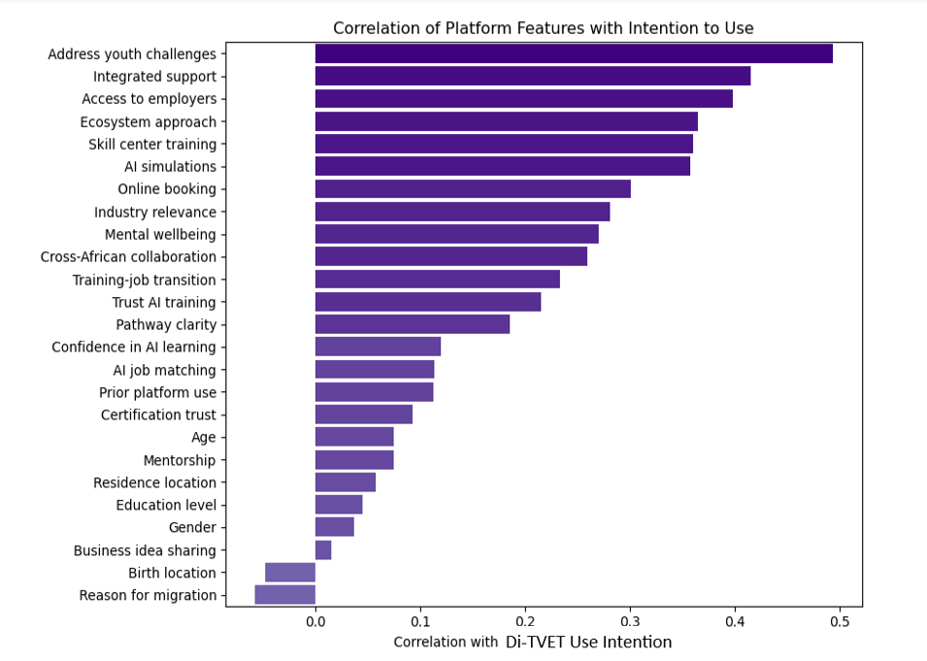
Figure 1: Correlation of platform features with intention to use
  - Group difference tests
Differences in responses across gender, prior use of a skill platform, location of birth and place of residence were examined using Mann-Whitney U test. The outcomes for comparison included willingness to use Di-TVET, perceived usefulness of AI simulations, trust in certificates and perceived access for low-income youth. Most outcomes showed no significant differences between groups with p > 0.05. That is willingness to use Di-TVET did not vary by gender (p = 0.746), prior platform use (p = 0.312), birth location (p = 0.674) and place of residence (p = 0.605). The exception was perceived usefulness of AI simulations, which differed by residence (p = 0.012). Both groups viewed AI simulations positively, with the urban dweller having a higher mean of 4.71 than their counter rural counterpart with a mean of 4.14. This can be attributed to better understanding of AI technology of the urban dwellers.

Kruskal-Wallis tests assessing whether participants’ perceptions of Di-TVET differed across age groups, highest level of education and reason for migration against various outcomes was carried out. The results indicate that most outcomes did not differ significantly across age groups or highest level of education (p > 0.05), suggesting that these demographic factors do not strongly influence participants’ perceptions of the platform. In the category of reason for migration, a few outcomes showed significant differences while trust in certificates has a p = 0.047), business idea-sharing encourages innovation (p < 0.01) and cross-African collaboration (p = 0.034). These findings suggest that participants’ migration backgrounds may influence how they perceive the credibility of certificates, business idea sharing platform and the potential for cross African collaboration.
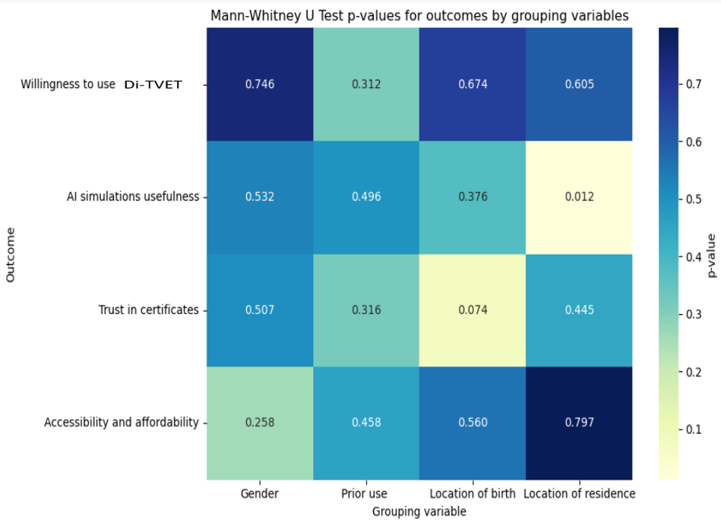
Figure 2: Mann-Whitney U test p-values
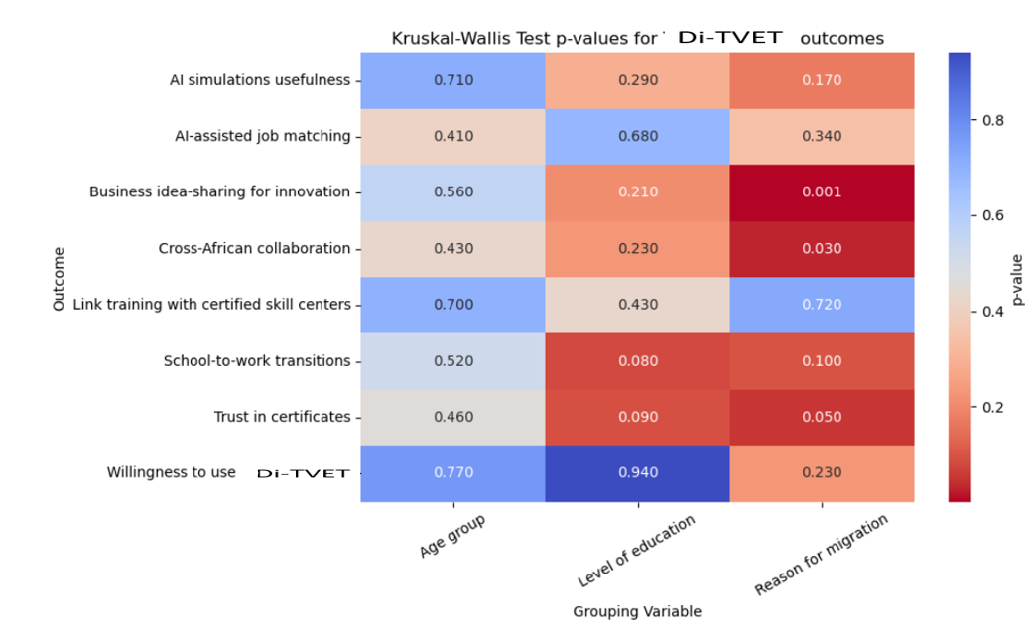
Figure 3: Kruskal-Wallis H test results
  - Ordinal logistic regression and model fit
Table 3 presents the results of the ordinal logistic regression examining the association between participants’ demographic characteristics, prior platform use and perceptions of the Di-TVET platform on their likelihood of using the platform. The model was estimated using maximum likelihood and model fit was evaluated using AIC and BIC. The estimated coefficients, standard errors, z-values, p-values and odds ratios which indicates the direction, magnitude and statistical significance of each predictor on the probability of platform use were obtained.
Table 3: Ordinal logistic regression model
Predictor | Coefficient | P-value | Odds ratio
Gender | -0.212 | 0.776 | 0.809
Location of permanent residence | -0.325 | 0.654 | 0.723
Age | -8.991 | 0.980 | 0.000125
Level of education | 0.184 | 0.768 | 1.202
Business idea component | -0.940 | 0.201 | 0.391
Psychological support component | 0.226 | 0.773 | 1.254
Prior use of training platform | 0.950 | 0.222 | 2.586
AI simulation | 0.506 | 0.362 | 1.659
Di-TVET training pathway | 1.322 | 0.043 | 3.751
Affordability of the system | 0.574 | 0.333 | 1.776
Most predictors of the model including gender, location of residence, age, education level, business idea component, psychological support, prior use, AI simulation and affordability of the platform, did not reach statistical significance, suggesting that these factors alone do not strongly predict reported use in this sample. Based on our odd ratio results, the gender ratio of 0.809 indicated that males are slightly less likely than females to report higher use of Di-TVET, participants from rural areas also show slightly lower adoption compared to urban residents, while higher education, prior platform use, AI simulation, psychological support and affordability showed modest increases in the likelihood of higher use. Notably, the training pathway had an odd ration of 3.751 which was the strongest predictor. Further, training pathway was the only significant predictor (coefficient = 1.322, p = 0.043). This indicates that the training pathway of theoretical modules to AI simulation to skill centers was significantly more likely to report higher use of the platform. This finding highlights that African youth increasingly value training programs that are job-aligned and skills-oriented, emphasizing pathways that directly lead to industry-relevant skills. The significance of the training pathway suggests that holistic training models integrating theory, practical simulations and real-world applications can strongly motivate youth engagement and uptake of digital trading platforms like Di-TVET. This provides a valuable insight into why many training initiatives in Africa have not been sustained over time or effectively addressed the unemployment challenge. Although demographic factors and platform features provide context, it is the clarity, relevance and structure of the training pathway that appears most influential in shaping youth decisions to engage with skills development platforms. This underscores the importance of designing vocational training that is accessible and aligned with real labor market demands. Finally, the model’s AIC and BIC values 77.53 and 104.1 respectively indicate a reasonable balance between fit and complexity, suggesting that the model adequately captures variation in participants’ reported use of Di-TVET. The ordinal regression values are illustrated in figure 4.
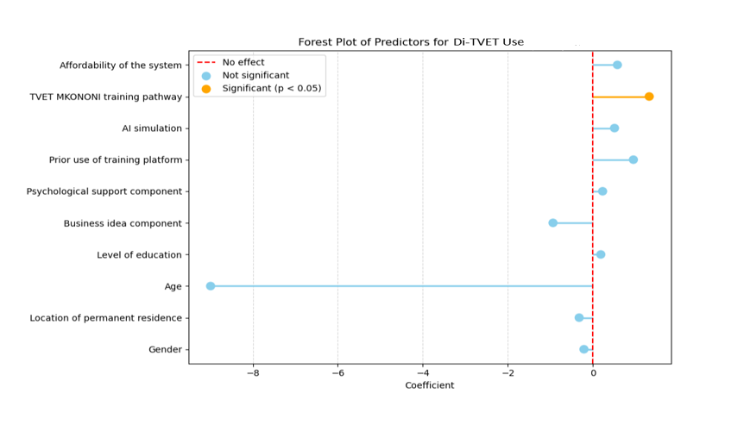
Figure 4: Ordinal regression values plot
- Conclusion
Pilot evaluation of Di-TVET AI-powered ecosystem model was conducted among youths aged 18-35, across rural, peri-urban and urban areas to assess acceptability, perceived relevance and predictors of adoption. The findings show overwhelming acceptance, with 100% of respondents expressing willingness to use the platform. Descriptive and non-parametric analyses indicate consistently high perceptions across demographic groups, demonstrating broad cross-sectional appeal. The structured training pathway from theoretical modules to AI simulations to certified skill centers emerged as the only statistically significant predictor of higher adoption hence underscoring the importance of coherent and job-aligned progression models. The integration of AI simulations, practical skill validation and entrepreneurship linkages within one ecosystem, this model addresses both employability and enterprise creation gaps. The results suggest that youth adoption of digital skill acquisition platforms is driven less by demographic characteristics and more by clarity, relevance and labor-market alignment of the training pathway. The proposed ecosystem therefore provides a scalable framework for strengthening school-to-work transitions and modernizing vocational education systems in resource-constrained contexts.

Conflict of interest
The authors declare that there are no competing interests or conflict of interest.

Funding
No funding was received for this study.

Ethical statement
The study did used human participants; informed consent was obtained and IRB approval grated by Kisii University ethical approval board.

References
- Audu, R., Yusri Bin Kamin, Y., & Balash, F. (2013). Technical vocational education: As a veritable tool for eradicating youth unemployment in Nigeria. International Journal of Humanities and Social Science Invention, 2(1), 49–56.
http://www.ijhssi.org/papers/v2(1)/Version-4/H0214956.pdf
- Begisheva, N. R. (2023). The mechanism for developing digital education skills. International Journal of Pedagogics, 3(12), 234–239. https://doi.org/10.37547/ijp/Volume03Issue12-43
- British Council. (2025). Unlocking African Youths’ Potential through International Higher Education Partnerships. British Council Nigeria.
https://www.britishcouncil.org.ng/sites/default/files/report_unlocking_african_youths_potential_through_international_higher_education_partnerships.docx.pdf
- Campos, D. G., & Scherer, R. (2024). Digital gender gaps in students’ knowledge, attitudes and skills: An integrative data analysis across 32 countries. Education and Information Technologies, 29, 655–693. https://doi.org/10.1007/s10639-023-12272-9
- Cieslik, K., Barford, A., & Vira, B. (2022). Young people not in employment, education or training (NEET) in Sub-Saharan Africa: Sustainable Development Target 8.6 missed and reset. Journal of Youth Studies, 25(8), 1126-1147. https://doi.org/10.1080/13676261.2021.1939287
- Ekpiken, W., & Ukpabio, G. (2015). Youth empowerment in higher education for sustainable development of developing communities in Cross River State, Nigeria. International Education Studies, 8(9), 113-121. https://doi.org/10.5539/ies.v8n9p113
- Frola, A., Delprato, M., & Chudgar, A. (2024). Lack of educational access, women's empowerment and spatial education inequality for the Eastern and Western Africa regions. International Journal of Educational Development, 104, 102939.
https://doi.org/10.1016/j.ijedudev.2023.102939
- Hope, K. R. Sr. (2012). Engaging the youth in Kenya: Empowerment, education, and employment. International Journal of Adolescence and Youth, 17(4), 221-236. https://doi.org/10.1080/02673843.2012.657657
- International Labour Organization. (2021). Digitalization of national TVET and skills systems: Harnessing technology to support lifelong learning (ISBN 978-92-2-035966-2) [PDF]. International Labour Office.
https://www.ilo.org/wcmsp5/groups/public/@ed_emp/@emp_ent/documents/publication/wcms_826682.pdf
- Işık, Ö. (2023). Tackle the tech skills shortfall for successful digital transformation. IMD. https://www.imd.org/ibyimd/innovation/tackle-the-tech-skills-shortfall-for-successful-digital-transformation/
- International Labour Organization, Brief (2024). Global employment trends for youth 2024: Sub-Saharan Africa (ILO Brief). International Labour Organization. https://doi.org/10.54394/QJUV5544
- Lampou, R. (2023). The integration of artificial intelligence in education: opportunities and challenges. Review of Artificial Intelligence in Education, 4(00), e15.
https://doi.org/10.37497/rev.artif.intell.educ.v4i00.15
- Mbugua, C., Kanyinga, K., & Mbatia, P. (2025). A reflection on challenges affecting youth empowerment programmes in Kenya. Journal of Agriculture, Science and Technology, 24(1), 107–121. https://doi.org/10.4314/jagst.v24i1.6
- Muhammad, S., & Kanon-Haki, N. A. (2025). Education as a tool for youth empowerment and sustainable development in Nigeria. Edumania-An International Multidisciplinary Journal, 3(04), 3-5. https://doi.org/10.59231/edumania/9156
- Muraina, I. O., & Emek, M. L. (2023). Harnessing and accelerating the acquisition and implementation of digital-technological-based skills for sustainable economic growth and development. ICONTECH International Journal, 7(2), 99–115. https://doi.org/10.5281/zenodo.10023083
- Mutisya, M., Muchira, J. M., & Abuya, B. A. (2021). Understanding wealth inequalities in education access in urbanizing Sub-Saharan Africa. Frontiers in Education, 6, Article 649730. https://doi.org/10.3389/feduc.2021.649730
- Nwogu, G. A. I. (2015). Barriers to equality of access to educational opportunity in Nigeria: A philosophical perspective. Journal of Education and Practice, 6(4), 148-155. http://www.iiste.org/Journals/index.php/JEP/article/view/15832
- Onyeiwu, S. (2024). Population, Youth Bulge and Economic Development. In: Emerging Issues in Contemporary African Economies. Palgrave Macmillan, Cham. https://doi.org/10.1007/978-3-031-74241-5_4
- Otto, S., Bertel, L. B., Lyngdorf, N. E. R., Markman, A. O., & Andersen, T. (2023). Emerging digital practices supporting student-centered learning environments in higher education. Education and Information Technologies, 29, 1673–1696.
- Princely. (2024, September 20). The impact of education on youth empowerment in Africa. Career Development Education.
https://www.tenabantu.org/blog/4#:~:text=The%20government%20has%20made%20efforts,practical%20skills%20in%20various%20trades
- Rahmawati, S., Abdullah, A. G., & Widiaty, I. (2024). Digital skills in technical and vocational education: A data-driven analysis of TVET competency trends. Journal of Vocational Education Studies.
- Rêgo, B. S., Lourenço, D., Moreira, F., & Pereira, C. S. (2023). Digital transformation, skills and education: A systematic literature review. Industry and Higher Education.
- Sele, S., & Mukundi, M. (2024). Youth empowerment in Africa: Challenges and opportunities. Global Journals. Vol. 14(2), pp. 187-196, 2024.
https://www.gjournals.org/2024/10/28/102024137-sele-and-mukundi/
- Shaikh, S. (2026). Digital transformation and skill acquisition. In Empowering learners with AI: Strategies, ethics, and frameworks. IGI Global.
- Shringarpure, A. (2023). Youth empowerment: Youth movements for the promotion of human rights. Geneva Centre for Human Rights Advancement and Global Dialogue. https://gchragd.org/wp-content/uploads/2023/04/Ashlesha-Shringarpure-research-paper.pdf
- Sifuna, D. N. (2020). The dilemma of technical and vocational education (TVET) in Kenya. Journal of Popular Education in Africa. 4(12), 4 – 22.
- Udeh, C., Daraojimba, R., Odulaja, B., Afolabi, J., Ogedengbe, D., & James, O. (2024). Youth empowerment in Africa: Lessons for U. S. youth development programs. World Journal of Advanced Research and Reviews, 21(1), 1942-1958.
https://doi.org/10.30574/wjarr.2024.21.1.2479
- United Nations Economic Commission for Africa. (2017). United Nations Economic Commission for Africa Youth Report. Office of the United Nations High Commissioner for Human Rights.
https://www.ohchr.org/sites/default/files/Documents/Issues/Youth/UNEconomicCommissionAfrica.pdf
- United Nations Office of the Special Adviser on Africa, African Union Commission, United Nations High Commissioner for Human Rights, Pan-African Parliament and United Nations Economic Commission for Africa. (2025). Office of the Special Adviser on Africa-United Nations. https://www.un.org/osaa/sites/www.un.org.osaa/files/subtheme_2_discussion_paper_final.pdf
- Wedekind, V., Russon, J.-A., Ramsarup, P., Monk, D., Metelerkamp, L., & McGrath, S. (2021). Conceptualising regional skills ecosystems: Reflections on four African cases. International Journal of Training and Development, 25, 347–362. https://doi.org/10.1111/ijtd.12251

