Techno-Economic and Environmental Assessment of Green Hydrogen Production from Renewable Energy Sources.
Abstract
The world energy shift to the low-carbon system has attracted the importance of green hydrogen as a clean and multi-purpose energy carrier. Green hydrogen, which is produced using water electrolysis that is fueled by renewable energy sources, is a promising approach to decarbonizing the industry, transportation, and power generation sectors that are difficult to abate. Nevertheless, it is impeded by its high cost of production, lack of intermittency of renewable energy and lack of integrated structures that can simultaneously assess the technical, economic and environmental performances. The aim of the study is to come up with an elaborate techno-economic and environmental appraisal scheme to compare hydrogen production systems that are renewable-powered. The simulation-based method was used to model the solar and wind and hybrid renewable energy system along with the electrolyzers to determine the hydrogen yield rates, system efficiency, use of energy and system operating parameters. Economic performance was determined based on capital and operational expenses, cost of hydrogen was made to be equal and payback years and environmental impacts were measured using life cycle assessment, which incorporated carbon emissions, energy use, and resource utilization. Findings show that hybrid solar-wind systems are better than single-source systems in terms of higher hydrogen generation, lower levelized cost of hydrogen (5.2 USD/kg H 2 ) and payback period and lower carbon footprint (0.8 kg CO 2/kg H 2 ). The combination framework offers a powerful method of system optimization and decision-making, which are useful to the policy makers, industry stakeholders, and researchers in developing cost-effective, efficient, and green hydrogen production systems.
Keywords: Green Hydrogen, Renewable Energy, Techno-Economic Assessment, Environmental Sustainability.

- Introduction
The energy sector around the world is in the radiant change of the urgent necessity to decrease the greenhouse gas emissions, increase the energy security, and discontinue the reliance of fossil fuels (Farghali et al., 2023). The global climate obligation and sustainability goals have heightened the endeavor of profound decarbonization of most sectors of the economy. Other renewable sources like solar, wind and hydropower have also been discussed as a potential alternative to the traditional source of energy that is fossil-based, since it has a low environmental impact and sustainability (Saleh & Hassan, 2024). These fast-tracked renewable technologies have helped in curbing the emission of carbon in the power industry. Nevertheless, it is difficult to have a completely decarbonized means of energy especially in the hard to abate industries like the heavy industry, transport over long distances and mass energy storage. Hydrogen in this regard has become a promising clean energy carrier because it has a high energy density, flexibility and can store and transport energy without release of greenhouse gases at the point of use (Hanson & Nwakile, 2025). Green hydrogen is hydrogen generated due to the electrolysis of water by a renewable energy source. Compared to the traditional hydrogen production processes that use fossil fuels, hydrogen can be produced by the renewable-powered electrolysis process with little adverse effect on the environment (Reda et al., 2024). Green hydrogen is becoming one of the most important elements of the worldwide energy transition since it can contribute to the process of decarbonization of various sectors. It can be used in industrial processes like steel and chemical production, in transportation in fuel cell vehicles, and in power industry as a storage of energy and a balancing of the grids. Although it has a large potential, there are a number of challenges associated with the mass deployment of green hydrogen production (Reda et al., 2024). Renewable energy sources are intermittent in nature so that there is some fluctuation in the supply of electricity, and thus the stability of hydrogen production systems is compromised (Menda et al., 2024). Further, electrolyzers are expensive equipment and infrastructure that makes the production of hydrogen more costly, further. Large scale usage of green hydrogen technologies is also curtailed by technical and operational complexities. Whereas most studies have been made on green hydrogen systems, many of them have been conducted in isolation in regard to technical performance, economic viability or environmental effects (Louli et al., 2025). These partial analyses tend to ignore interaction and trade-offs between these key aspects. As a result, there exist no wholesome frameworks that can be used to concurrently measure the technical efficiency, economic viability and environmental sustainability (Ait Sidhoum et al., 2022). This study aims to develop an integrated techno-economic and environmental assessment framework for evaluating the feasibility, performance, and sustainability of renewable-powered green hydrogen production systems.
1.1 Problem statement
Green hydrogen has become a potential way of decarbonization being used to help the world move to the sustainable energy system. It has a low-carbon alternative to fossil-based hydrogen by generating hydrogen via renewable-powered electrolysis, which could have a major impact in eliminating emissions in industries, transport, and power generation (Elegbeleye et al., 2025). The widespread implementation of green hydrogen technologies is, however, limited by a number of challenges. Capital expenses are high which includes the costs of electrolyzers, renewable energy infrastructure, and hydrogen storage systems, all of which have a large impact on the economic viability (Msweli et al., 2025). Moreover, the issues concerning the maturity of technology and performance during operations also represent uncertainties that make the investment decisions more complicated. The variability of electricity supply by renewable energy sources like solar and wind also introduces variability in the availability of renewable energy leading to changes in the reliability and efficiency of hydrogen production systems (Bassey et al., 2024). The current research tends to examine the technical performance, economic viability, or environmental impact individually and thus provide piece-meal information. Therefore, the absence of an integrated techno-economic and environmental assessment framework restricts the optimization of the system, policy planning, and investment strategies of the production of green hydrogen based on renewable sources.

2.0 Literature Review
2.1 Global Energy Transition and Decarbonization
The issue of the global energy transition has taken center stage in the quest to contain climate change and attain long-term sustainability (Oruwari & Ogbuike, 2023). The global climate treaties like the United Nations Framework Convention on Climate change and Paris agreement has highlighted the fact that the world needs to act quickly to cut down greenhouse gas emission and curb global warming (Leal-Arcas et al., 2025). Decarbonization of most countries has thus seen the strategies to cut back on the use of fossil fuels and increase the use of renewable energy sources like solar, wind and hydro-power. Despite a major increase in renewable electricity generation, it is difficult to have deep decarbonization in heavy industry and other areas aviation, shipping, and long-term energy storage (Aina, 2024). Such industries demand high-energy-density fuels and flexibleness energy drivers that may be utilized to supplement intermittent renewable energy frameworks. This has resulted in the growing interest of alternative energy carriers in the global energy transition (Chygryn & Shevchenko, 2023). Hydrogen, and especially green hydrogen generated in renewable electrolysis has been deemed as a possible solution that could help facilitate large-scale decarbonization and help a more resilient and sustainable global energy system.
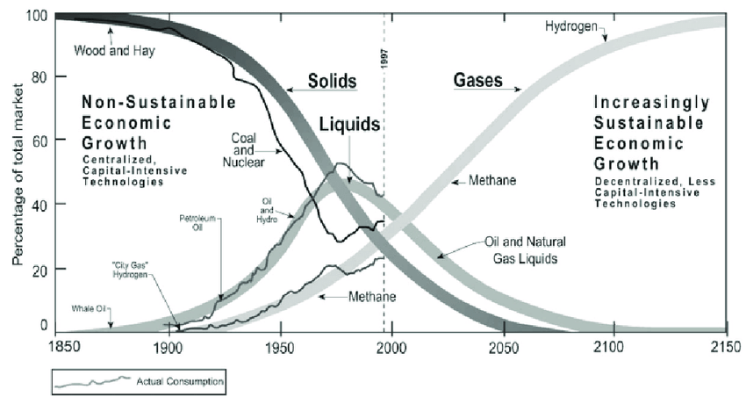
Figure 1: Global Energy system Transition (Chowdhury et al., 2017)
2.2 Hydrogen as a Clean Energy Carrier
Hydrogen is an energy carrier that has been receiving mounting interest as a clean and flexible energy carrier that can facilitate the shift toward low-carbon energy systems. Hydrogen economy refers to a scenario whereby energy system is used whereby hydrogen is massively produced, stored, and used as a significant energy source to substitute fossil fuel in various industries (Pereira et al., 2024). Compared to traditional fuels, hydrogen does not form an acid that may be harmful to the environment as it is converted to water when used through fuel cells or combustion engines. Hydrogen in the present day energy systems has a number of significance such as energy storage, transportation fuel, industrial feedstock, and a way of balancing the supply and demand of electricity (Sarmah et al., 2023). It is also able to hold excess electricity produced by the renewable energy sources and transform it into a usable fuel by the process of electrolysis. Such a feature increases the flexibility of the grid and enables massive integration of renewable energy. Therefore, hydrogen is becoming one of the essential elements in the creation of sustainable, secure, and decarbonated energy systems (Yan et al., 2020).

2.3 Renewable Energy for Hydrogen Production
The renewable energy sources are very essential in facilitating the production of hydrogen in a sustainable manner especially in the form of green hydrogen produced by electrolysis of water using clean electricity (Marouani et al., 2023). Solar photovoltaic (PV) systems have been described as among the most widely applied renewable technologies that directly use sunlight into electricity to drive electrolyzers in the production of hydrogen (Ghosh, 2025). The solar PV systems appeal because of their scalability and their decreasing prices and the fact that they are available in most regions. Another significant source of hydrogen generation through renewable electricity is the wind energy systems, which has a large energy production and their generation is quite constant in the appropriate places (Jones & Olsson, 2017). Electrolysis systems using wind can effectively generate hydrogen, especially where there are high and reliable wind sources. However, both solar energy and wind energy are intermittent in nature, and this may influence the stability of hydrogen production (Nasser et al., 2022). In order to overcome this shortcoming, there has been a growing interest in hybrid renewable energy sources that utilize several sources, including solar and wind, to enhance energy reliability, system efficiency, and the general performance of hydrogen products.
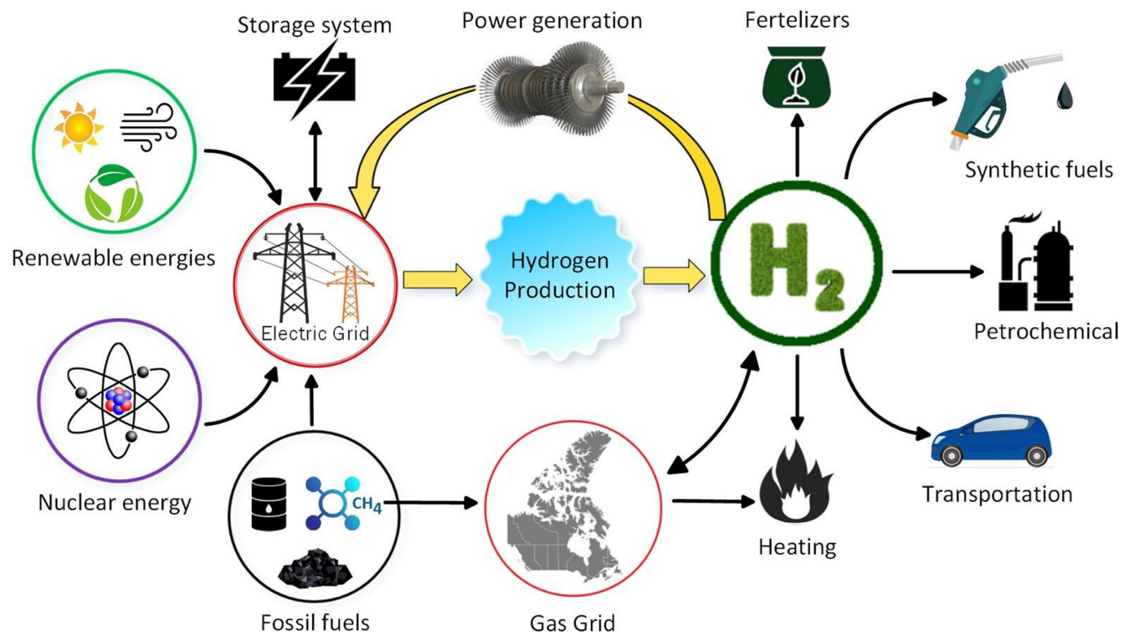

Figure 2: Renewable Hydrogen Production (Agyekum et al., 2022)

3.0 Methodology
3.1 Data Collection
Reliable simulation datasets were used to retrieve data in this study, and the data is used to aid the techno-economic and environmental analysis of the renewable-based green hydrogen production systems. Electricity generation models based on solar photovoltaic and wind energy systems were modeled using the data of renewable energy resources such as solar irradiance and wind speed. To simulate hydrogen generation processes, technical parameters associated with the performance of the electrolyzers were included (efficiency, operating conditions, and hydrogen production rates). In addition, the cost information related to renewable energy systems and hydrogen production technologies, both capital and operating costs, were part of the analysis. Simulation datasets used in life cycle assessment, including greenhouse gas emissions and energy consumption, were also obtained based on the relevant data of environmental impact.
3.2 Data Pre-Processing
The datasets collected before model development went through a systematic data pre-processing step to guarantee data accuracy and consistency. Data cleaning and verification was first done to eliminate errors, inconsistencies and duplication in the data of renewable energy and system parameters. The gaps in the datasets were detected and addressed with the help of the required estimation or interpolation methods. This was followed with normalization of the data and conversion to uniform units in order to be compatible in the simulation model. The renewable energy data including the solar irradiance and wind speed was subjected to time-series processing to extract the temporal variation in the energy availability. Lastly, pertinent variables and parameters needed in system simulation were also chosen to facilitate proper modelling of the production systems of green hydrogen.
3.3 Model Evaluation
The simulation models produced were tested to be accurate, reliable, and practical in the assessment of renewable-based green hydrogen production systems. Sensitivity analysis was performed to explore the impacts of changes in the essential input parameters, including availability of renewable energy, the efficiency of the electrolyzer, and cost of operating the systems, on the performance of the system and economic results. The various system scenarios, such as solar-powered, wind-powered, and hybrid renewable hydrogen systems were compared to determine the most efficient configuration and cost-effective ones. To ensure the validity of technical, economic, and environmental forecasts, model validation was done by comparing the results of the simulation with published data and literature benchmark models. The evaluation metrics were performance measures such as system efficiency, rate of hydrogen production and the vital cost measures of levelized cost of hydrogen (LCOH) and payback period. This holistic assessment made sure that the combined framework would be insightful in designing, operating, and maintaining green hydrogen production systems to be optimized.

4.0 Results
Table 1: Technical Performance Results
System Configuration | Hydrogen Production Rate (kg/day) | System Efficiency (%) | Energy Utilization (%)
Solar PV Hydrogen System | 120 | 65 | 70
Wind-Powered Hydrogen System | 150 | 68 | 75
Hybrid Solar-Wind System | 180 | 72 | 80

The table 1 indicates that hybrid solar-wind systems have a better performance in all the essential technical metrics as compared to the single solar or wind systems. At 180 kg/day, the production of hydrogen is the maximum as it shows the joint availability of the two sources of energy. The system efficiency, as well as the energy utilization, is also enhanced to 72 and 80 percent, respectively, which suggests more efficient conversion of the renewable electricity to hydrogen. Solar only systems perform the least because of intermittency whereas wind only systems perform averagely. In general, the hybrid configurations offer the most stable and effective solution to the green hydrogen production.
Table 2: Economic Analysis Results
System Configuration | CAPEX (USD) | OPEX (USD/year) | Levelized Cost of Hydrogen (USD/kg) | Payback Period (years) | Financial Feasibility
Solar PV Hydrogen System | 1,200,000 | 120,000 | 6.5 | 12 | Moderate
Wind-Powered Hydrogen System | 1,000,000 | 110,000 | 5.8 | 10 | Good
Hybrid Solar-Wind System | 1,500,000 | 130,000 | 5.2 | 9 | High

The table 2 indicates that hybrid solar-wind hydrogen systems with the highest capital expenditure (CAPEX) yield the lowest levelized cost of hydrogen (5.2 USD/kg) and the shortest payback period (9 years), which represents a high level of financial viability in the long term. Wind-only systems are moderately CAPEX and LCOH, having an advantage compared to solar-only systems, which is the highest LCOH (6.5‛ USD/kg) and the longest payback period (12 years). Overall, hybrid architectures are the most economical and economically sustainable solution to producing green hydrogen, as they offer a compromise between investment and profitability.
Table 3: Environmental Impact Results
System Configuration | Carbon Emissions (kg CO₂/kg H₂) | Energy Consumption (kWh/kg H₂) | Resource Impact (water use, L/kg H₂)
Solar PV Hydrogen System | 1.2 | 55 | 3.5
Wind-Powered Hydrogen System | 1.0 | 52 | 3.2
Hybrid Solar-Wind System | 0.8 | 50 | 3.0

The table 3 shows that hybrid solar-wind hydrogen systems are the least harmful to the environment of the configurations examined. The carbon emissions are cut down to 0.8 kg CO 2/kg H 2, in comparison to 1.2 kg CO 2/kg of solar-only and 1.0 kg CO 2/kg wind-only systems. It also consumes the minimum amount of energy of 50 kWh H 2, and the minimum amount of water used is 3.0 L H 2. Such findings contribute to better efficiency in integrating renewable sources and minimizing the environmental impact, which makes the hybrid designs the most sustainable to produce green hydrogen to achieve decarbonization.
Table 4: Comparative Scenario
Parameter | Solar PV System | Wind System | Hybrid Solar-Wind System
Hydrogen Production Rate (kg/day) | 120 | 150 | 180
System Efficiency (%) | 65 | 68 | 72
Energy Utilization (%) | 70 | 75 | 80
Levelized Cost of Hydrogen (USD/kg) | 6.5 | 5.8 | 5.2
Payback Period (years) | 12 | 10 | 9
Carbon Emissions (kg CO₂/kg H₂) | 1.2 | 1.0 | 0.8
Energy Consumption (kWh/kg H₂) | 55 | 52 | 50
Water Use (L/kg H₂) | 3.5 | 3.2 | 3.0

The table 4 indicates that hybrid solar-wind systems are more profitable, technically, and environmentally than solar-only and wind-only systems. The maximum hydrogen is produced at 180 kg/day with better system efficiency (72) and use of energy (80). On the economic level, hybrid systems have the lowest levelized price of hydrogen (5.2 US dollar/kg) and the shortest payback time (9 years). They emit the least carbon (0.8 kg CO 2/kg H 2), use less energy and use the least amount of water, environmentally. Overall, the hybrid arrangements present the most stable, affordable, and sustainable one as far as producing green hydrogen is concerned.

4.1 Discussion
The findings of this research indicate that hybrid solar-wind hydrogen production systems are always better in technical, economic, and environmentally than single-source ones. The rate of hydrogen production of 180 kg/day in the hybrid system is higher than the rates of solar-only and wind-only systems, which can be regarded as the benefit of using a combination of complementary renewable resources to reduce intermittency and enhance the reliability of the system. The hybrid configuration was also more efficient and conserved more energy, which, again, supports the results reported in previous research that hybrid renewable systems increase the efficiency of energy conversion and stability of operations (Nnabuife et al., 2024; Abirami et al., 2025). The hybrid system had the lowest levelized cost of hydrogen (5.2 US D / kg) and the lowest payback period (9 years) which were supported by evidence presented in Oyekale et al. (2020) that the combination of multiple renewable sources can lower the total cost and enhance the financial viability. The solar-only systems were noted to have the best LCOH and the greatest payback, which demonstrates the difficulty of using intermittent solar resources exclusively. The hybrid system has the lowest carbon emissions (0.8 3 kg CO 2/kg H2) and the least amount of energy used and water used environmentally. This corresponds to the literature that highlights the environmental advantages of green hydrogen made using renewable sources and the importance of the design of the integrated system in ensuring sustainable production (Angelico et al., 2025; Ma et al., 2025). In general, the results prove that the hybrid renewable hydrogen systems provide a best combination of technical, economical, and environmental feasibility.

5.0 Conclusion
This study evaluated technical, economical and environmental performance of a green hydrogen manufacturing system that employs renewable energy sources with the help of a combined framework consisting of a simulation. The results show that the hydrogen systems using renewable energy sources are technologically feasible, and the hybrid solar-wind systems prove the highest rates of hydrogen production, better system efficiency, and energy use, as opposed to the single-source solar and wind systems. On the economic side, hybrid systems have the most competitive performance, where the lowest levelized cost of hydrogen and the shortest payback period is achieved, which is also indicative of its economic feasibility at large scale. Environmentally, the production of hydrogen renewed on an environmental basis leads to a reduced emission of carbon, energy usage, and resource usage in comparison to traditional fossil-based hydrogen, which confirms the possibility of green hydrogen to contribute to the global objectives of decarbonization. The integrated assessment framework that was established in this research was useful in the simultaneous analysis of technical, economic and environmental factors, as it was able to understand trade-offs and interactions within the system configurations. This study indicates that hybrid renewable hydrogen systems are the best in terms of performance, cost, and sustainability. The resulting framework and insights can inform the policy-makers, industry players, and researchers to design, optimize, and scale green hydrogen production systems that can have a positive impact on a low-carbon energy transition.
5.1 Recommendations
Based on the findings of this study, several recommendations can be made to enhance the feasibility, efficiency, and sustainability of green hydrogen production systems.
- Improvements in electrolyzer technologies: By creating high efficiency, durable, and scalable electrolyzers, novel materials and designs, hydrogen production is increased, minimizing energy losses, lowering the capital and operating expenses of the system, and providing reliable and cost-effective and economically viable green hydrogen systems on a large scale.
- Policies to reduce hydrogen production costs: Incentives such as subsidies, tax breaks and grants on research can attract investment within the green hydrogen technologies, and the facilitating market incentives and regulatory regimes can make renewable-based hydrogen systems more appealing, sustainable and competitive enough to be widely implemented.
- Integration of hybrid renewable energy systems: Integrating solar, wind, and other renewable sources will decrease intermittency and make the systems more reliable, whereas optimizing hybrid configurations will allow the use of the maximum of the energy and guarantee better efficiency and cost-efficiency, making the production of green hydrogen more predictable and cost-efficient.
- Future research on large-scale hydrogen infrastructure: Studies are needed on storage, transport, and distribution of hydrogen, undertake long-term techno-economic and environmental analysis in real world conditions, and come up with strategies of optimizing systems to achieve sustainable, scalable, and efficient green hydrogen generation to be used on a large scale.

Reference
Agyekum, E. B., Nutakor, C., Agwa, A. M., & Kamel, S. (2022). Renewable hydrogen production: A review of scale-up challenges and future potential. Membranes, 12(2), 173. https://doi.org/10.3390/membranes12020173
Ait Sidhoum, A., Dakpo, K. H., & Latruffe, L. (2022). Trade-offs in farm sustainability: Evidence from Spanish crop farms. PLoS ONE, 17(1), e0261190. https://doi.org/10.1371/journal.pone.0261190
Aina, O. (2024). Decarbonization challenges and opportunities for developing nations. American Journal of Computing and Engineering, 7, 1–12. https://doi.org/10.47672/ajce.1761
Bassey, K., Aigbovbiosa, J., & Agupugo, C. (2024). Risk management in renewable energy investment. Zenodo, 11, 138–148. https://doi.org/10.5281/zenodo.13311076
Chowdhury, P., Malekshoar, G., & Ray, A. (2017). Dye-sensitized photocatalytic water splitting and sacrificial hydrogen generation: Current status and future prospects. ResearchGate. https://doi.org/10.13140/RG.2.2.20598.29760
Chygryn, O., & Shevchenko, K. (2023). Trends and drivers in energy industry development. SocioEconomic Challenges, 7(1), 115–128. https://doi.org/10.21272/sec.7(1).115-128.2023
Elegbeleye, I., Oguntona, O., & Elegbeleye, F. (2025). Green hydrogen and climate change mitigation. Hydrogen, 6(2), 29. https://doi.org/10.3390/hydrogen6020029
Farghali, M., Osman, A. I., Mohamed, I. M. A., Chen, Z., Chen, L., Ihara, I., Yap, P. S., & Rooney, D. W. (2023). Strategies to save energy during the energy crisis. Environmental Chemistry Letters, 21, 1–37. https://doi.org/10.1007/s10311-023-01591-5
Ghosh, A. (2025). Solar-powered green hydrogen production via electrolysis. Solar RRL, 9(7), 202500150. https://doi.org/10.1002/solr.202500150
Hanson, E., & Nwakile, C. (2025). Carbon capture and storage as a pillar for energy transition. Engineering and Technology Journal, 10(8), 2456–3358. https://doi.org/10.47191/etj/v10i08.12
Jones, L. E., & Olsson, G. (2017). Solar and wind energy for water provision. Global Challenges, 1(5), 1600022. https://doi.org/10.1002/gch2.201600022
Leal-Arcas, R., Alghamdi, A., & Alharethi, M. (2025). Effectiveness of the UNFCCC and Paris Agreement. SSRN. https://doi.org/10.2139/ssrn.5396993
Louli, R., Giurgea, S., Salhi, I., Laghrouche, S., & Djerdir, A. (2025). A critical review of green hydrogen production by electrolysis. Energies, 19(1), 59. https://doi.org/10.3390/en19010059
Marouani, I., Guesmi, T., Alshammari, B. M., Alqunun, K., Alzamil, A., Alturki, M., & Hadj Abdallah, H. (2023). Integrating green hydrogen into future energy systems. Processes, 11(9), 2685. https://doi.org/10.3390/pr11092685
Menda, B. P., Ganesh, P., Koneti, V., Mohanrao, A., Swathi, A., & Manoj, V. (2024). Renewable energy integration in modern power systems. E3S Web of Conferences, 591, 03002. https://doi.org/10.1051/e3sconf/202459103002
Msweli, N., Ude, G. N., & Richards, C. (2025). Green hydrogen for off-grid energy access in Sub-Saharan Africa. Energies, 18(18), 5035. https://doi.org/10.3390/en18185035
Nasser, M., Megahed, T., Ookawara, S., & Hassan, H. (2022). Water electrolysis systems powered by solar and wind energy. Environmental Science and Pollution Research, 29, 85341–85365. https://doi.org/10.1007/s11356-022-23323-y
Oruwari, H., & Ogbuike, O. (2023). Sustainable energy transition and climate change in Nigeria. SPE Nigeria Annual International Conference and Exhibition. https://doi.org/10.2118/217136-MS
Pereira, J., Souza, R., Oliveira, J., & Moita, A. (2024). Hydrogen production, transport, and storage: A review. Clean Technologies, 6(3), 1260–1313. https://doi.org/10.3390/cleantechnol6030061
Reda, B., Elzamar, A. A., AlFazzani, S., & Ezzat, S. (2024). Green hydrogen and the path to sustainability. Environment, Development and Sustainability, 27, 29213–29233. https://doi.org/10.1007/s10668-024-04892-z
Saleh, M. H., & Hassan, A. I. (2024). Challenges in renewable energy transition. Applied Chemical Engineering, 7(2), 2084. https://doi.org/10.59429/ace.v7i2.2084
Sarmah, M. K., Singh, T. P., Kalita, P., & Dewan, A. (2023). Sustainable hydrogen generation and storage: A review. RSC Advances, 13(36), 25253–25275. https://doi.org/10.1039/d3ra04148d
Yan, Z., Hitt, J. L., Turner, J. A., & Mallouk, T. E. (2020). Renewable electricity storage via electrolysis. Proceedings of the National Academy of Sciences, 117(23), 12558–12563. https://doi.org/10.1073/pnas.1821686116

